Practical 11:

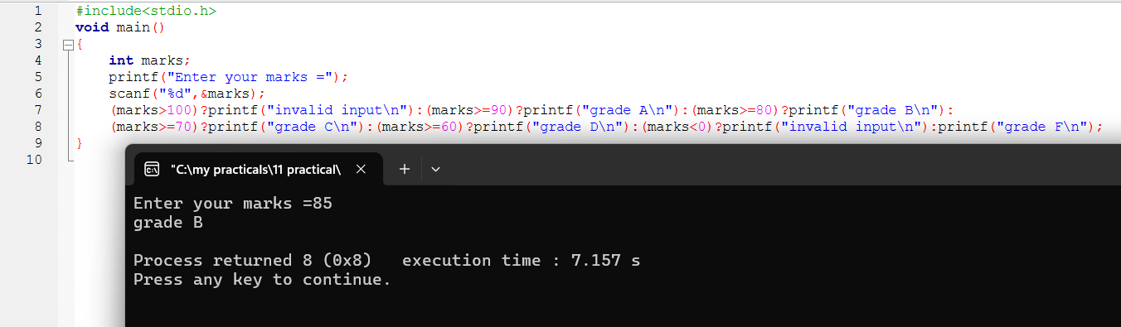

11-i:

11-iii:

11-iv:

11-v:

